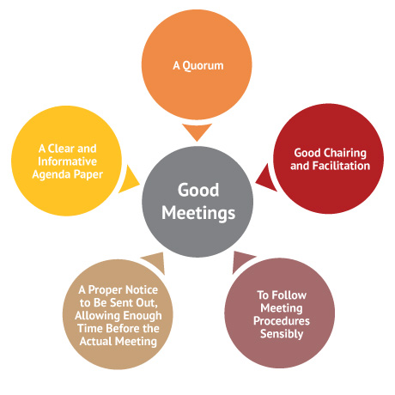

An organisation’s meetings are a fundamental part of the governance process. But there are some common problems, such as:

- no-one knows the ground rules
- a few people dominate the discussion
- the CEO runs the meeting
- some people never turn up
- there are no information papers
- no one records decisions
- the discussion goes off track all the time.

So people get frustrated, bored and the meeting doesn’t accomplish much.
Good meetings don’t just happen. A well-run meeting needs:

- a shared purpose
- an agenda
- agreed rules
- a quorum
- meeting minutes
- an effective chair or facilitator
- some healthy food and a sense of humour.

