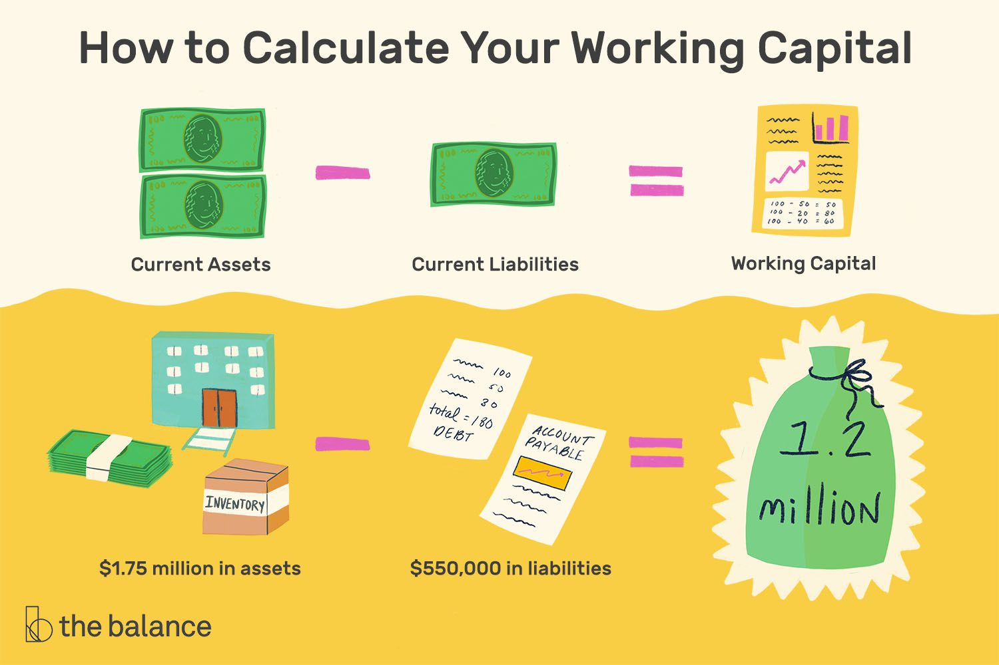

The Balance Sheet shows us whether the council has working capital, or money available to keep the council going.

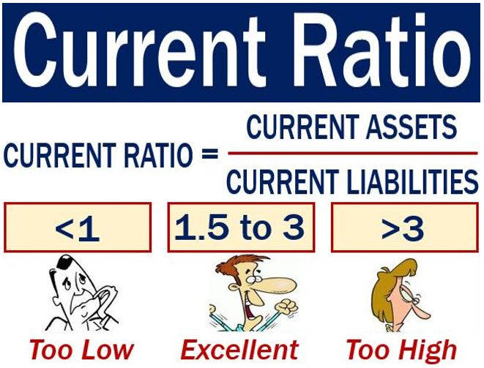
Less than 1 means that the council may not be in a position to pay debts when they fall due. | 1.5 to 3 is a good ratio. It means Council has more than enough to pay debts but is not hanging onto too much either. | More than 3 means the council is not spending its money on services and infrastructure for the community.

