Guide to MyLearning

How to access:
- The training courses are available on MyLearning at https://mylearning.nt.gov.au/.
- Click on the log in button on the top right hand side.
- Log in using your personal username and password that have been provided to you.
- Click the Dashboard tab at the top left of the page, and then click on My Dashboard.
- The six courses should appear in the list on the left.
They are:
- Understanding Local Government
- Roles and Responsibilities
- Introduction of the Code of Conduct
- Understanding Conflict of Interest
- Introduction to Council Finances
- Council Decision Making and Meeting Procedures
- Click on one of the three courses and it will take you to the course.
The course will look like the below:

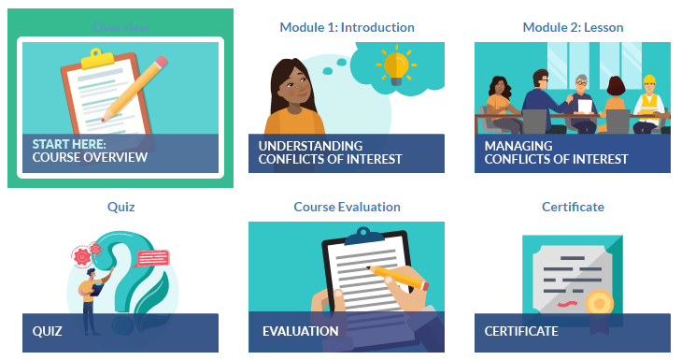

The lesson:
- Start by clicking on the Overview.
The Overview window will open and provide information about the course aims and requirements. Please read through before commencing Module 1.
- Click on Module 1: Introduction. Watch the video provided.
- Proceed to Module 2: Lesson. Read through the information and proceed to the next page by clicking NEXT.
- Once you have read through all of the information, click FINISH LESSON.
- Congratulations, you can now take the quiz.
- If you are ready to take the quiz, click the blue link Go to Activity 3.1 – Quiz.
- If you need to read the information again, click on Return to Introduction to the Code of Conduct.

Completing the quiz:
To complete the quiz and gain your certificate, you must get a grade of 10/10.
- When you are ready, click ATTEMPT QUIZ NOW.
- Select your answer or answers (some questions allow one or more answers).
- Click CHECK before proceeding.
- If your answer is correct, you will get a correct notification with an explanation.
- If your answer is incorrect, you will be given an option to REDO QUESTION.
- If you have selected a few options but not all of them, you will get a notification that your answer is partially correct. Click on the REDO QUESTION option and select all answers that apply.
- Once you have checked your answer and it is correct, you can proceed by clicking on NEXT PAGE in the bottom right hand corner.
- You can also navigate to different questions down the bottom.
- Once you are done, click on Finish attempt and then click on SUBMIT ALL AND FINISH.

The evaluation and Certificate of Completion
- Click on the blue Evaluation link to complete some feedback about the course. Your feedback will help us improve this course for future participants. There are no right or wrong answers.
- Once you have completed your course evaluation, please click on SUBMIT YOUR ANSWERS.
- You can now receive your certificate. Click on the GET CERTIFICATE button.
- Your certificate will open as a PDF, you can download, save and print it.

